Cirrhosis Patient Survival Prediction

name | id
Ezzeldein yasser Hassan | 206879

Used libraries:
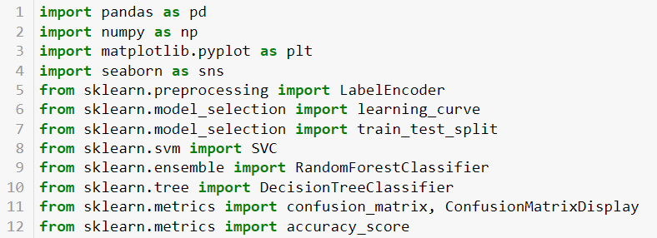
1. pandas: Data manipulation and analysis library for structured data.
2. numpy: Fundamental library for numerical computations.
3. matplotlib.pyplot: Data visualization library for creating plots.
4. seaborn: Data visualization library for attractive statistical graphics.
5. LabelEncoder from sklearn.preprocessing: Encodes categorical labels as numbers.
6. learning_curve from sklearn.model_selection: Visualizes model performance based on training data size.
7. train_test_split from sklearn.model_selection: Splits data into training and testing sets.
8. SVC from sklearn.svm: Support Vector Classifier for classification.
9. RandomForestClassifier from sklearn.ensemble: Implements random forest classification.
10. DecisionTreeClassifier from sklearn.tree: Implements decision tree-based classification.
11. confusion_matrix and ConfusionMatrixDisplay from sklearn.metrics: Evaluate classification model performance with confusion matrix.
12. accuracy_score from sklearn.metrics: Calculate classification model accuracy.

First validate the dataset to identify and handle duplication and null values , crucial for ensuring data integrity before training a machine learning model. Subsequently, employ a label encoder function to convert string features into numerical data, a necessary step for machine learning models to process the information effectively. Visualize the data to unveil patterns and relationships, aiding in feature engineering and model selection. Common visualization methods include heatmaps, histograms, and scatterplots. Proceed by dividing the data into training and testing sets. The training set educates the model, while the testing set evaluates its performance on unseen data, guarding against overfitting. Train the machine learning model by feeding it the prepared training data, selecting an algorithm suited to the problem at hand. Evaluate the model's performance using metrics like accuracy, precision, recall, and F1 score on the testing set to assess its generalization capability. Fine-tune the model's hyperparameters cautiously to enhance performance, avoiding overfitting due to aggressive adjustments. Lastly, create and visualize a confusion matrix to assess the model's predictive performance across different classes. This matrix showcases the model's correct and incorrect predictions, offering a comprehensive view of its effectiveness.
Before drop nulls
Figure 1
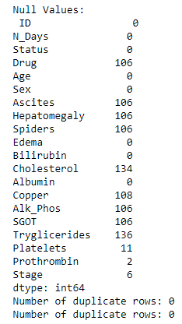
After drop nulls
Figure 2
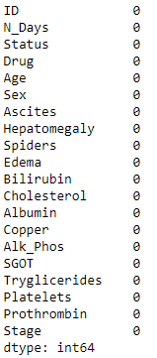

Correlation on all of data set
Figure 3
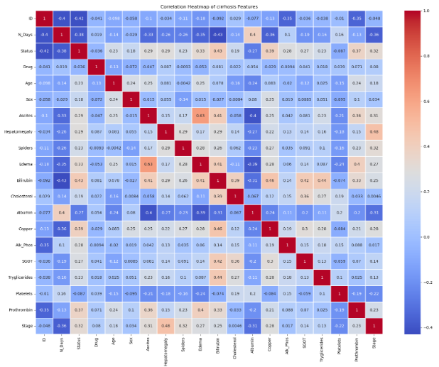

Visualization 1
Figure 4
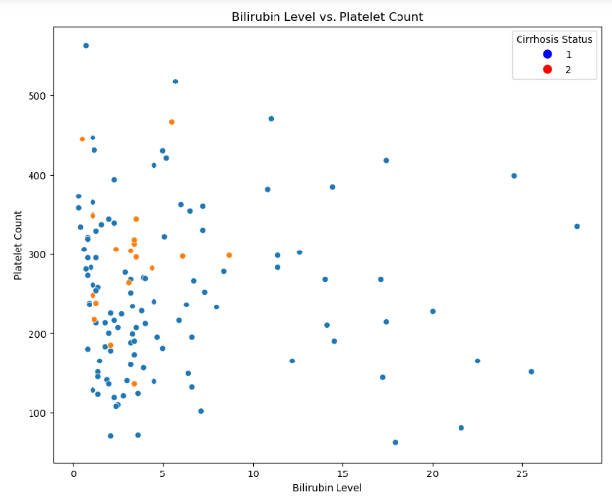
Visualization 2
Figure 5
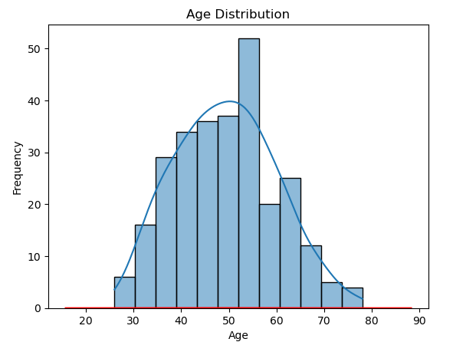
SVM model learning curve
Figure 6
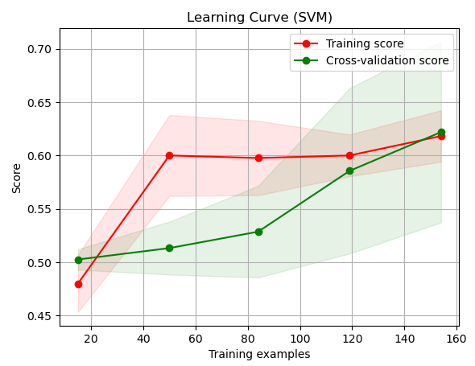
Random forest learning curve after fix overflow problem
Figure 7
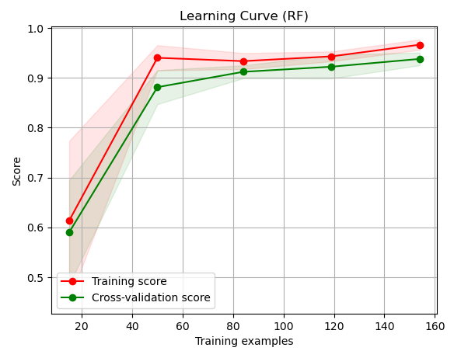

Decision tree model after fix overflow problem
Figure 8
